IMPLEMENTING WEB APPLICATION

|  |  |
| --- | --- |
| Date | 8th November 2022 |
| Team ID | PNT2022TMID38955 |
| Project Name | Plasma Donor Application |

Create IBM DB2 And Connect with Python

* Login to IBM Cloud Account

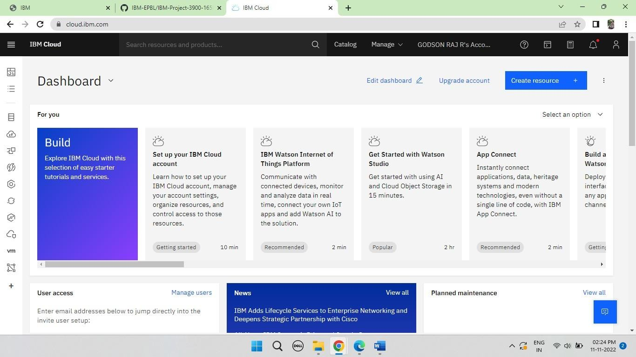

* Search for IBM DB2 and Create a DB2 service

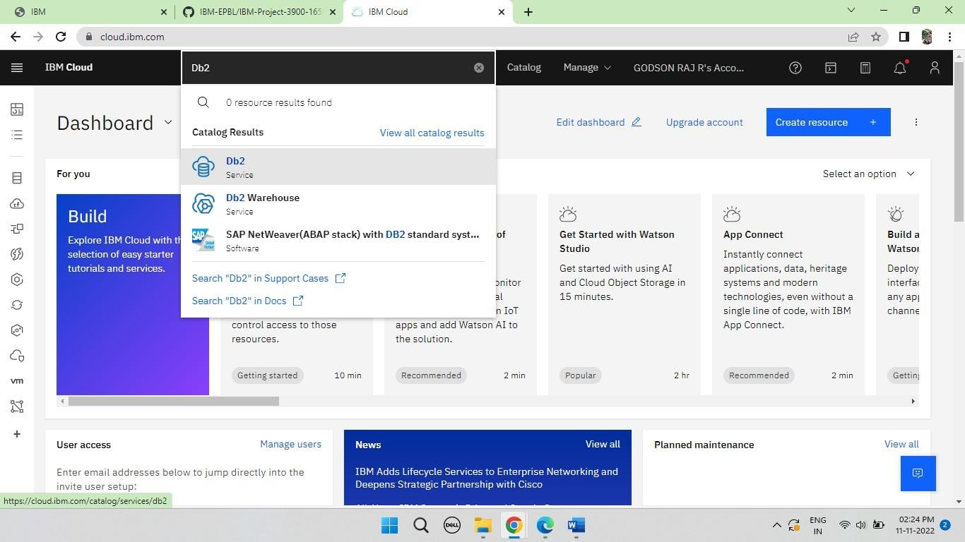

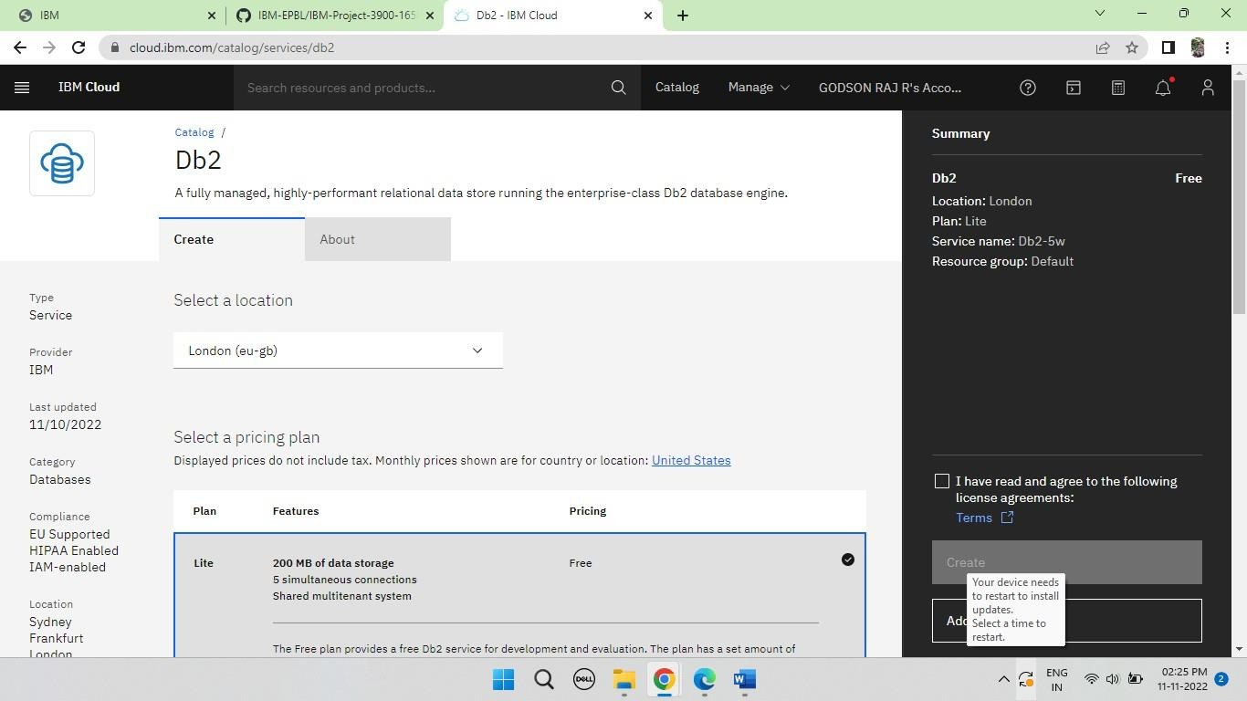

* + Go to Resources and select IBM db2

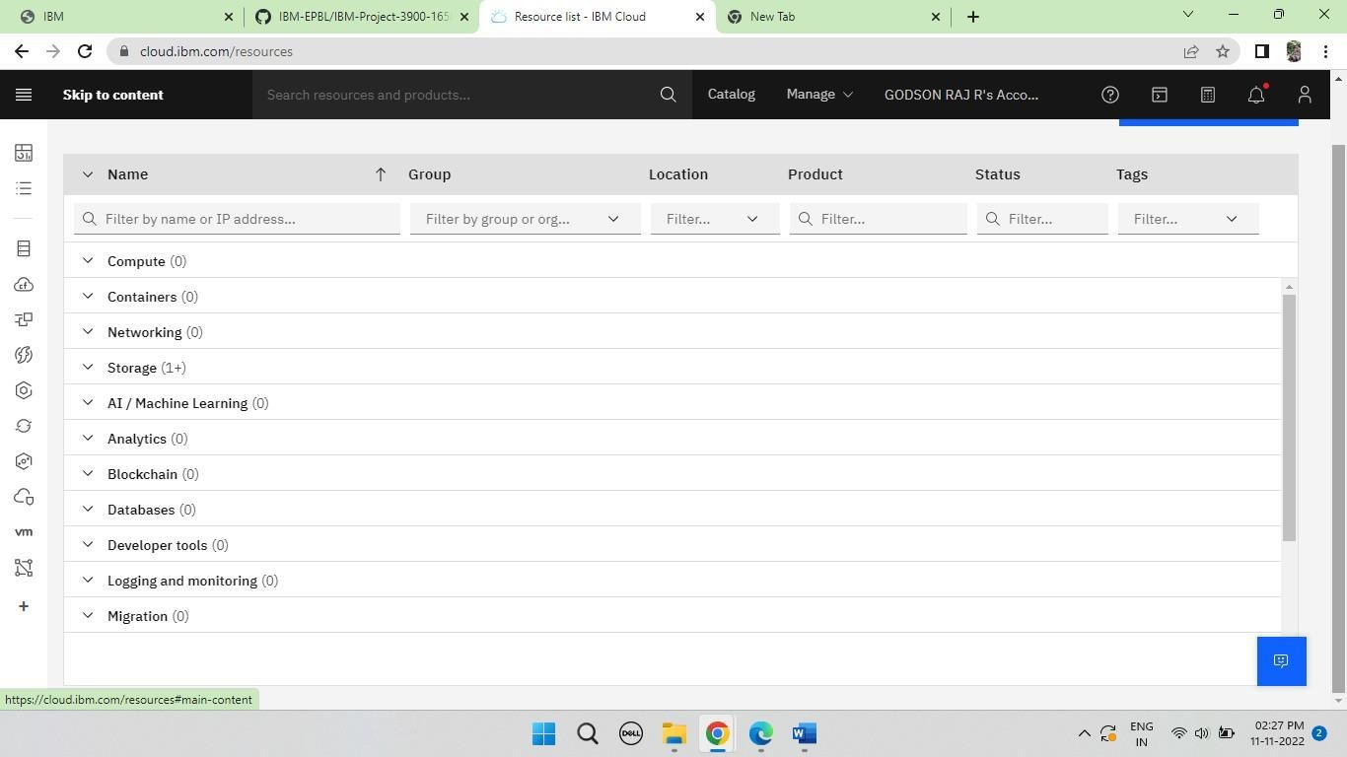

* + Create New Service credentials and Go to UI

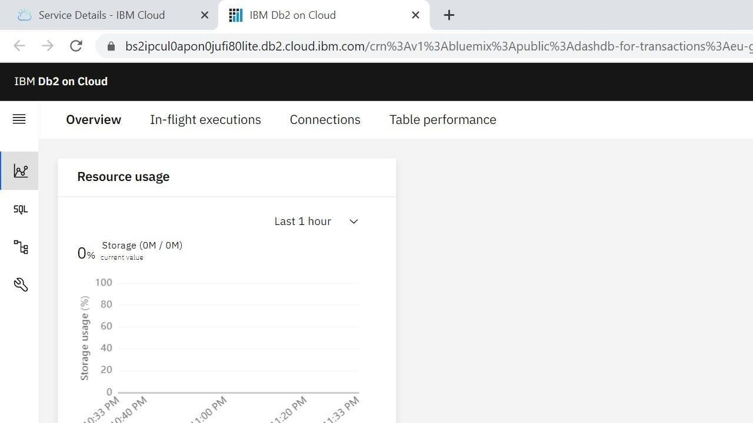

* + Paste those credentials in the python code

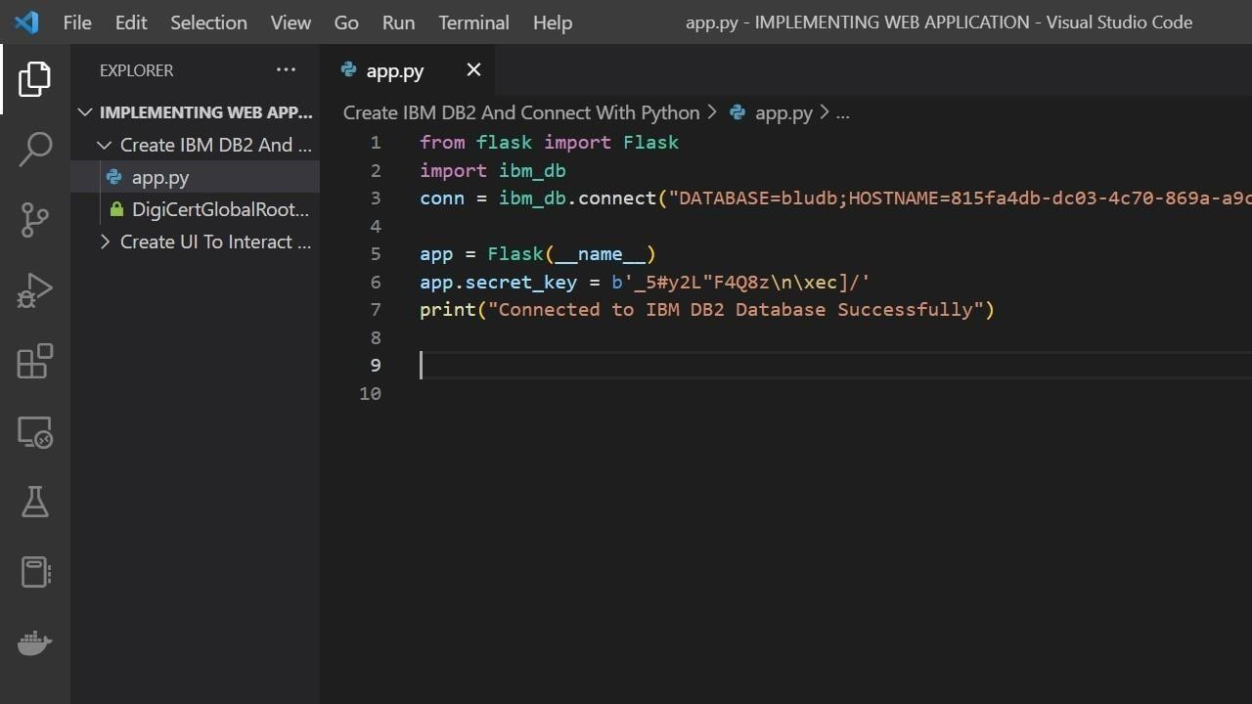

* Run the python code in cmd

